Scientific Goal:

The project “Small band-gap nanostructured perovskite materials for photovoltaic and photocatalytic hydrogen generation applications” investigates oxide and oxynitride materials thin films exhibiting photovoltaic and photocatalytic activity for solar water splitting. The project’s objectives are to find the optimal conditions for controlled growth of thin films of BiFeO3 (BFO) and cation doped BFO as well as LaTi(O,N)3, BaTa(O,N)3, CaTa(O,N)3, YSi(O,N)3 and YGe(O,N)3 with different nitrogen content and to correlate the structural, crystallographic, electrical and surface properties with their photovoltaic and photocatalytic activity.

Research work and results:

Thin film deposition of LaTiO3-xNx was successfully performed using Pulsed Reactive Crossed‐Beam Laser Ablation (PRCLA). Different nitrogen content was achieved by varying the laser fluence and the substrate temperature.

The chemical content of the fabricated samples was investigated by Rutherford Back Scattering (RBS) and Energy Recoil Detection Analysis (ERDA). X-Ray Diffractometry (XRD) was used for the identification of the crystalline structure and the epitaxial symmetry (Fig. 1). The transmittance of the films was measured by UV/Vis/near-IR Spectrometry in the wavelength range between 300 and 2000 nm (Fig. 2). From these measurements it was possible to correlate the energy band-gap of the fabricated samples as a function of the N content and the crystalline structure.

The XRD pattern of fig. 1 shows the (002) and the (004) LaTiO3-xNxreflection peaks on the left-hand side of the LaAlO3 substrate peaks. The film grew epitaxially oriented with the deposition substrate and showed small degree of misalignment between adjacent crystallites, as revealed by the measurement of the FWHM of the (002) rocking curve (about of 0.075°).

Fig. 2 shows the transmission spectra of aLaTiO3-xNx thin film. By decreasing the N content the absorption edge moved towards smaller wave lengths, while an increased N content resulted in a shift of the absorption edge towards larger wave lengths, thus covering a larger portion of the visible light spectral range. Additionally, a test experiment has been performed to investigate the electronic structure of our oxynitride thin films by resonant inelastic X-ray scattering (RIXS) at the Swiss Light Source (SLS) of PSI. For this feasibility test, thin films of lanthanum titanium oxide with and without N incorporation into the O site were fabricated. Very promising results, recently submitted for publication, were obtained analyzing a thin film of La2Ti2O7-δ.A dedicated SLS scientific proposal will be soon submitted to extend this investigation on the oxynitride compounds to study the effect of N-doping on the electronic structure.

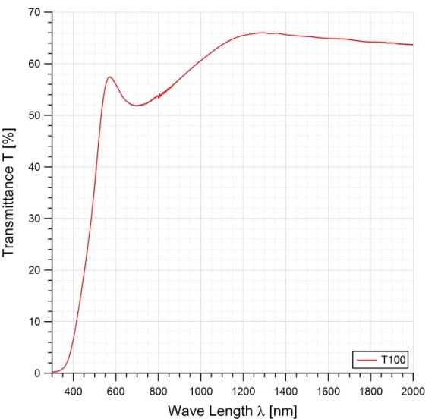 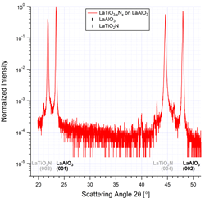

Figure 1: XRD pattern of a LaTiO3-xNx-film on a LaAlO3-substrate. Figure 2: UV/Vis transmission spectra of a LaTiO3-xNx-film.

BFO thin films have been grown by Pulsed Laser Deposition. Several types of substrates have been used due to specific requirements for testing the optical, electrical and structural properties, as well as photocatalytic activity. The approach for the BFO samples was to obtain both polycrystalline and epitaxial thin films.

Epitaxial BFO thin films were grew on electrical conductive SrRuO3- buffered SrTiO3 (SRO/STO) and Nb-doped SrTiO3 (STON) substrates; they have been morphological, structural and optical investigated prior to sending them to PSI for photocatalytical activity evaluation. For both BFO/SRO/STO and BFO/STON films, from XRD patterns only (00l) reflections of the BFO layer can be observed, with no evidence of other misoriented peaks (Figure 3). In the case of BFO/SRO/STO thin film a slightly higher c-lattice parameter has been found, c=4.022 Ǻ, as compared with c=3.962Ǻ for bulk perovskite BFO structure. This fact can be attributed to the in-plane isotropic compression of the BFO layer due to lattice mismatch with the SRO/STO substrate (c=3.910Ǻ-SRO). The optical properties of the films were particularly investigated by spectroscopic ellipsometry technique. The band gap value Eg= 2.71 eV for the BFO/SRO/STO thin film was calculated from Tauc plot: (αE)2=f(E), α=4πk/λ being the absorption coefficient (Figure 4).



Figure 3: XRD pattern of a BFO-film on a SRO/STO-substrate. Figure 4: The band gap value for BFO/SRO/STO thin film

A set of epitaxial BFO thin films have been sent to PSI for photoelectrochemical characterization and to MDEO group from University of Bucharest for temperature-dependent current-voltage (I-V) and transient photocurrent measurements, respectively.

Polycrystalline BFO thin films have been deposited on (Pt/TiO2/SiO2/Si) substrates. The layers deposited at 7000C exhibits a higher crystallinity/larger grains respect to the sample deposited at 6500C, as can be seen from the XRD patterns details presented in Figure 5; however the higher deposition temperature has the detrimental effect of parasitic PtxSiY phases apparition due to the chemical reaction between Pt and Si. The films exhibits a band gap value of Eg=2.8 eV, as can be seen from Figure 6.

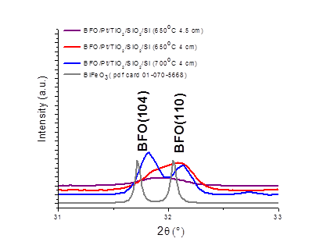 

Figure 5: XRD pattern of a BFO-film on a BFO/Pt/TiO2/SiO2/Si-substrate. Figure 6: The band gap value for BFO/Pt/TiO2/SiO2/Si thin film

List of tasks and milestones for the first year:

1) Thin film characterization with standard techniques: **successfully accomplished**

2) Film deposition of LaTiO3-xNx with variable N content using PRCLA: **successfully accomplished**

3) Test of photocatalytc activity: **deviation from the original road map**

Due to a change in personnel in the *Catalysis Group* at *PSI*, the test of the photocatalytic activity of our samples has been performed in collaboration with the *Laboratory for Solid State Chemistry and Catalysis* at *EMPA*. The photocatalytic activity has been investigated by measuring the photo-induced electrical current. For this characterization an electronic conducting buffer layer is required to collect the photo-induced charge carriers. This buffer layer must fulfill several requirements; besides being a good electronic conductor at room temperature, this film should provide the required lattice matching and thermal expansion coefficient to promote an ordered growth of the oxynitride layer. Moreover, the buffer layer must be chemically stable at high temperature in strongly reducing environment since the oxynitride films are deposited at about 800°C in N and ammonia containing atmosphere. A metal layer, like Pt for example, is expected to induce crack in the oxynitride film due to the significantly different thermal expansion coefficients. SrRuO3and ZnO were used but these materials showed very poor chemical stability in reducing environment. We are now investigating the use of TiN as conducting buffer layer. This material can be grown in-situ by PLD epitaxially oriented with Si (0001) or MgO (001) oriented substrates. TiN is a good electronic conductor, very stable at high temperature in reducing environment and showed good chemical compatibility with LaTiO3-xNx. Very promising results have been achieved and we are now optimizing the fabricating procedure.

4) Deposition of other N doped oxides and test: **postponed**

The investigation of different oxynitride materials was postpone to the next year due to technical problems with the substrate heating system and to the additional work that was required for the fabrication of the conducting buffer layer for the photoelectrochemical characterization (see number 3).

5) Deposition of BiFeO3 and doped BFO: partially accomplished

The BFO thin films have been successfully deposited on different substrates and their morphological, structural and optical characterization has been done. The cation doped-BFO thin films growth has been delayed due to some problems related with the targets quality (relative density of the target) provided by the supplier. The new targets of cation (Lanthanum) doped BFO will arrive at the middle of February. Samples of epitaxial and polycrystalline BFO thin films produced by PLD have been sent to PSI testing their photocatalytical activity and to MDEO group from University of Bucharest for electrical characterization.

6) Additional milestones not initially planned:

A scientific collaboration with PSI Large Scale Facility Swiss Light Source was started. Successful fabrication of La2Ti2O7-δsamples was performed for RIXS characterization. This research project will continue for the characterization of the N-doped samples.

Deviation from the research plan:

The characterization method of the catalytic activity of the oxide and oxynitride thin films was changed (see number 3 and 5 above).

The RIXS investigation of the electronic structure of our oxynitride films has been added as an additional research line in collaboration with SLS for the characterization of these materials.

The cation doped BFO thin films deposition had to be delayed due to poor quality of the received La-doped BFO targets (low relative density). This activity will be performed this year. Instead, first deposition of perovskite YSiO2N oxynitride has already been done and samples of YSON thin films are under characterization with standard techniques (AFM, XRD, SIMS, SEM).

Research output:

**Conference:**

* N.D. Scarisoreanu, R. Birjega, M.Dumitru, C. Ghica, L.C. Nistor, F. Craciun, M. Dinescu, Oxide Thin Films with Perovskitic Structure for Nanotechnology, Invited Lecture E-MRS Fall Meeting, Warsaw, 16-20 September 2013
* N. D. Scarisoreanu, R. Birjega, V. Ion, F. Craciun, V. Teodorescu, T. Lippert and M. Dinescu, Functional properties of BFO nanostructures produced by laser ablation, submitted to E-MRS Spring Meeting, Lille, 26-30 May 2014

**Publications:**

Submitted: Jakub Szlachetko, Markus Pichler, Daniele Pergolesi, Jacinto Sá and Thomas Lippert: *Determination of conduction and valence band electronic structure of La2Ti2O7 thin film*